Hey! We have a little test task for you. There are no restrictions, only the result is important.

You need to create a simple image classifier for Chronic obstructive pulmonary disease.   
  
These links can be helpful:

1. [https://medpix.nlm.nih.gov/home](https://www.researchgate.net/deref/https%3A%2F%2Fmedpix.nlm.nih.gov%2Fhome)
2. [http://www.radiologyeducation.com/](https://www.researchgate.net/deref/http%3A%2F%2Fwww.radiologyeducation.com%2F)
3. [http://www.jsrt.or.jp/jsrt-db/eng.php](https://www.researchgate.net/deref/http%3A%2F%2Fwww.jsrt.or.jp%2Fjsrt-db%2Feng.php)
4. [http://www.via.cornell.edu/databases/](https://www.researchgate.net/deref/http%3A%2F%2Fwww.via.cornell.edu%2Fdatabases%2F)
5. [http://radiologyed.org/resourcelibrary/](https://www.researchgate.net/deref/http%3A%2F%2Fradiologyed.org%2Fresourcelibrary%2F)
6. [http://lifeinthefastlane.com/table/radiology-database/](https://www.researchgate.net/deref/http%3A%2F%2Flifeinthefastlane.com%2Ftable%2Fradiology-database%2F)

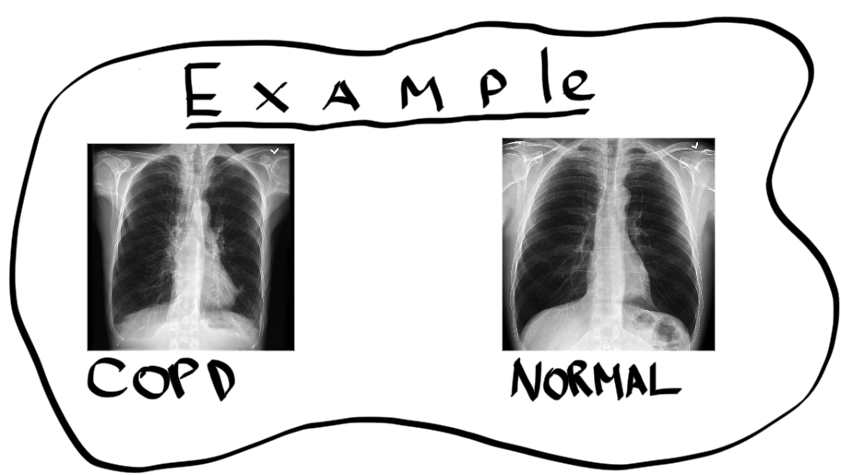

[To the Trello card ->](https://trello.com/c/BLtCj6sQ/328-copd-classifier)